Guiding Questions for Immigration Cartoons

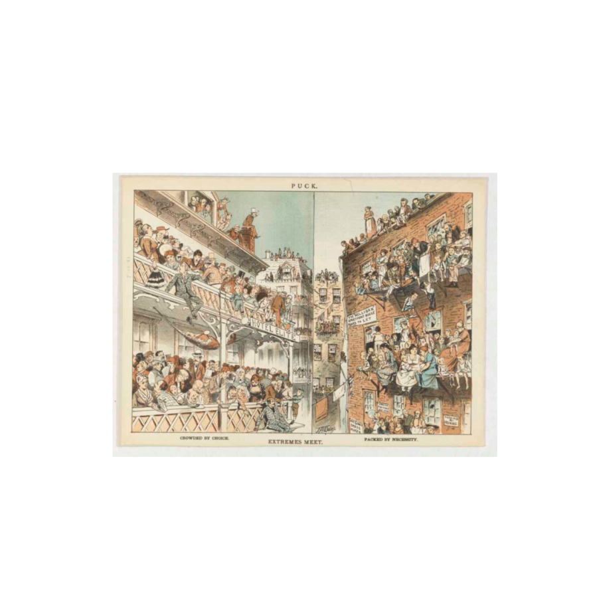
Extremes Meet- 1881

- Who is being represented in the left side of the cartoon? Where are they? Who is being represented in the right side of the cartoon? Where are they?
- What differences do you notice between the people in the oppostie sides of the cartoon?
- What do you think the cartoon is saying about the lives of immigrants? What about the lives of the elite?
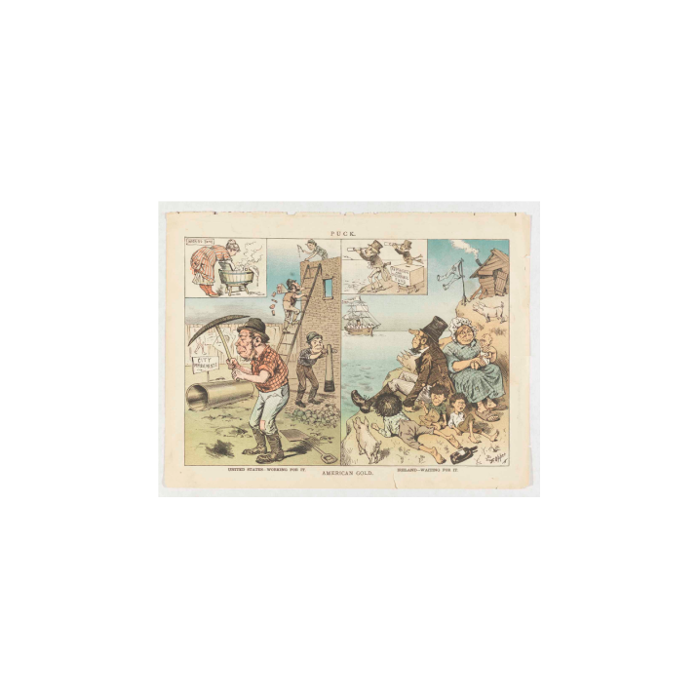
American Gold- 12150- anti-Irish- 1882

- What country is represented on each side of the cartoon?
- What are the people doing on each side of the cartoon? How are their actions different?
- What animal is on the right side of the picture? What do you think this animal represents?
- Keeping in mind the title of the cartoon and the captions on either side, what is this cartoon about? Who is it critiquing and why?

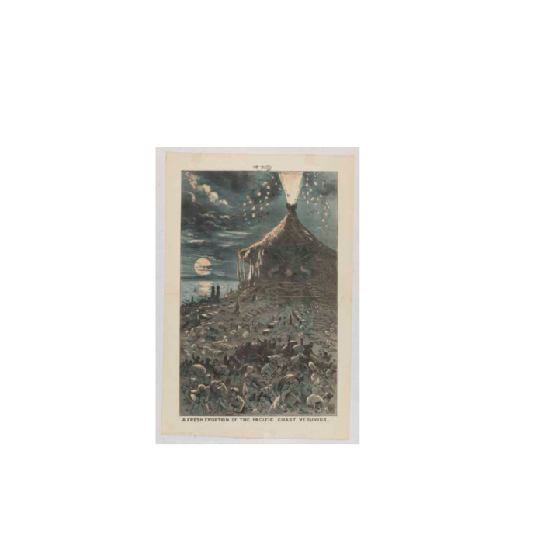
A Fresh Eruption of Pacific Coast Vesuvius - 1882

- What is coming out of the volcano? What is the mountain shaped like? Who is this cartoon about?
- What words are coming from the volcano? What do you think these phrases mean in the context of immigration?
- Who is running away from the volcano?
- What do you think the message of this cartoon is?
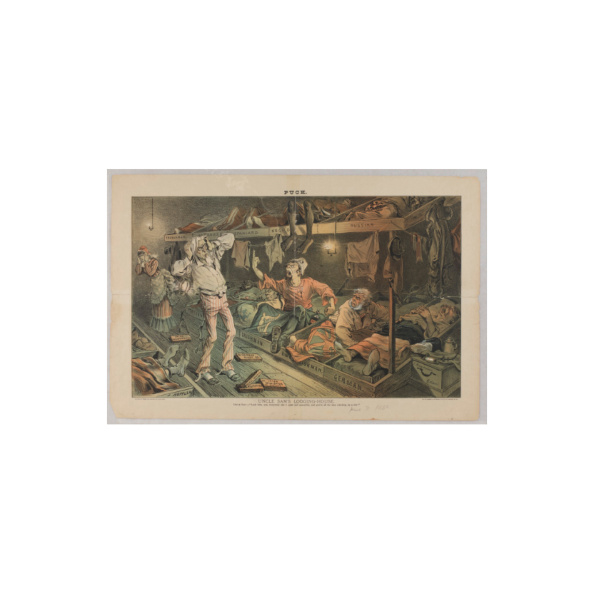

Uncle Sam’s Lodging House- 1882

- What do you think the metaphor of “Uncle Sam’s Lodging House” means? Who are sleeping in the beds?
- How is the Irishman depicted? What does he have in bed with him?
- What do the bricks on the ground say? Who do you think threw them?
- What does the caption say? What do you think the message of this cartoon is?
- How are the other nationalities depicted?

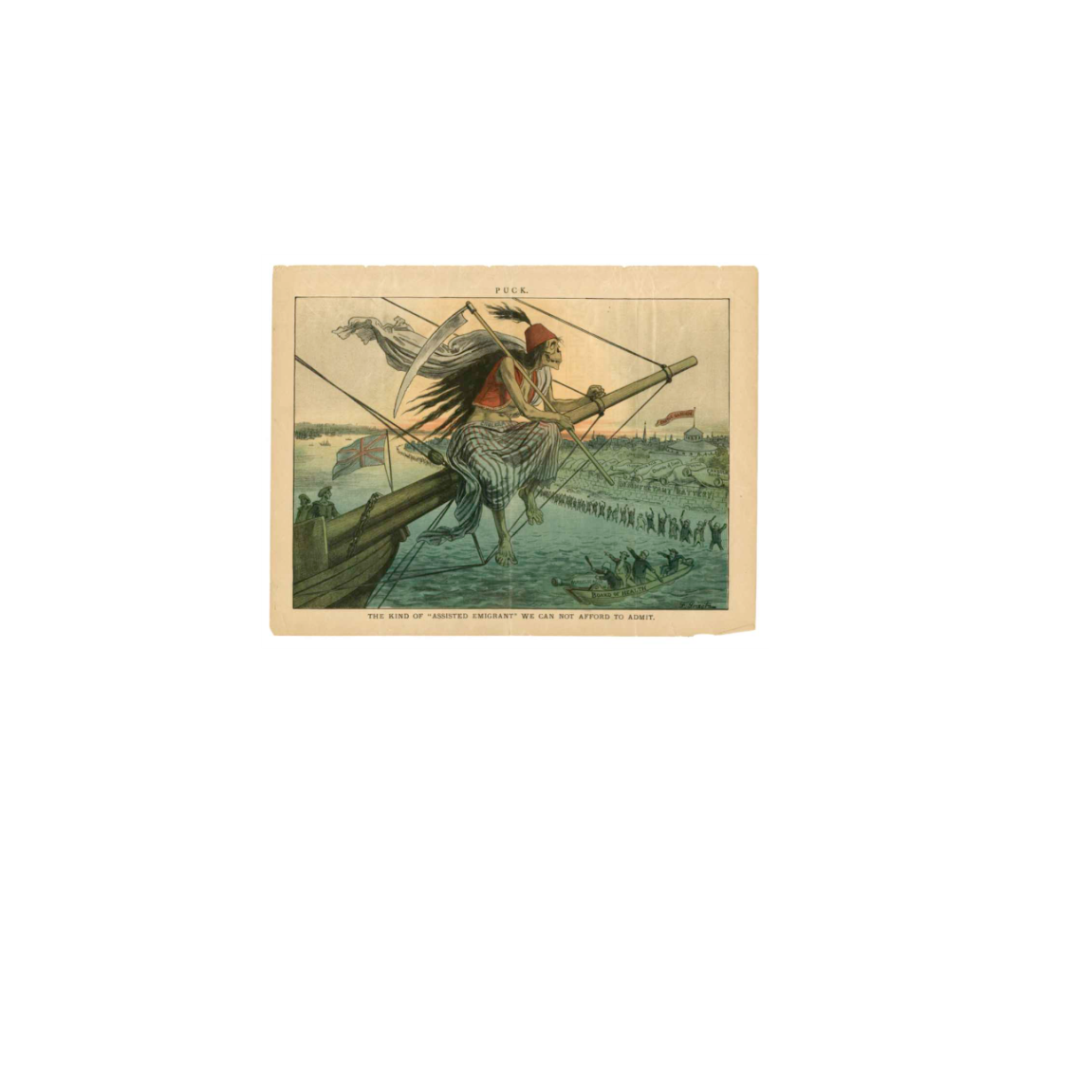
The Kind of "Assisted Emigrant" We Can't Afford to Admit- 1883

- What does the man with the scepter represent?
- Who is in the boat?
- What does the skeleton’s blanket say? What does this mean?
- What do you think the bottles on the shore represent?
- According to this cartoon, why can’t the U.S. “afford to admit” this immigrant?

